**MINI PROJECT**

**Title**

Forecasting Software Developer Salaries: A Machine Learning Approach.

Project made by:

1.Prem Kalamkar (56)

2.Neel Kothimbire (62)

3.Sumeet Kumbar (66)

**Objectives**

* To Collect relevant data on software developer salaries.
* To Identify key features that influence software developer salaries.
* To Build a predictive model using machine learning algorithms.
* To Evaluate the performance of the model and refining it for better accuracy..

**Outcomes**

* A predictive model capable of estimating the salary of software developers with a high degree of accuracy.
* Insights into the factors that most significantly impact software developer salaries.
* Potential applications in HR and recruitment processes for salary negotiations and budget planning.

**Software**

* Programming Language: Python
* Libraries: Scikit-learn, Pandas, NumPy, Matplotlib/Seaborn, Streamlit.
* Tools: Jupyter Notebook, Anaconda

**Theory**

Machine Learning Approach:

* Supervised Learning: In supervised learning, the model learns from labeled data, where each example is paired with a corresponding target variable. In the context of your project, the target variable would be the salary of software developers, and the model learns to predict this variable based on input features.

Feature Selection:

* Identifying Relevant Features: The success of your salary prediction model depends on selecting the right features that have a significant impact on software developer salaries. These features may include programming languages, years of experience, education level, location, industry, and company size, among others.

Model Selection:

* Regression Algorithms: Since your project involves predicting a continuous variable (salary), regression algorithms are suitable for the task. Common regression algorithms include Linear Regression, Ridge Regression, Lasso Regression, Random Forest Regression, Gradient Boosting Regression, and Support Vector Regression, among others.

Hyperparameter Tuning:

* Each regression algorithm comes with its set of hyperparameters that control the behavior of the model. Hyperparameter tuning involves selecting the optimal combination of hyperparameters to maximize the model's performance. Techniques such as grid search or randomized search can be used for this purpose.

Evaluation Metrics:

* Mean Absolute Error (MAE): MAE measures the average absolute difference between the predicted salaries and the actual salaries. It provides a straightforward interpretation of prediction error in the same units as the target variable (salary).
* Mean Squared Error (MSE): MSE measures the average squared difference between the predicted salaries and the actual salaries. It penalizes larger errors more heavily than MAE, making it sensitive to outliers.
* R-squared (R2): R-squared represents the proportion of variance in the target variable (salary) that is explained by the independent variables (features) in the model. It ranges from 0 to 1, where higher values indicate a better fit of the model to the data.

Data Preprocessing:

* Handling Missing Values: Missing values in the dataset need to be addressed before training the model. Techniques such as imputation (replacing missing values with a calculated estimate) or deletion of missing values can be employed.
* Scaling and Normalization: Scaling numerical features ensures that all features contribute equally to the model fitting process and prevents features with larger scales from dominating the model.
* Encoding Categorical Variables: Categorical variables need to be encoded into numerical format for model training. Techniques such as one-hot encoding or label encoding can be used depending on the nature of the categorical variables**.**

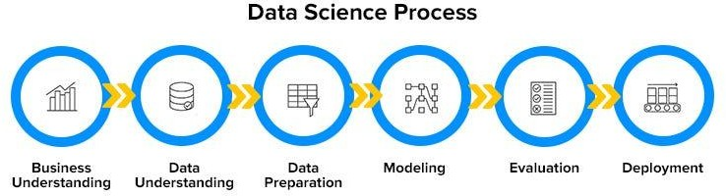

**Algorithm:**

1. Data Collection:
   * Gather data on software developer salaries from reliable sources such as job boards, company websites, salary surveys, or APIs.
   * Include relevant features such as years of experience, education level, programming languages, location, industry, company size, etc.
2. Data Preprocessing:
   * Handle missing values by imputation or deletion.
   * Encode categorical variables using techniques like one-hot encoding.
   * Scale numerical features to ensure they have similar magnitudes.
   * Split the data into training and testing sets to evaluate the model's performance.
3. Feature Engineering:
   * Explore feature relationships and engineer new features if necessary.
   * Consider transformations or combinations of features to better represent the underlying patterns in the data.
4. Model Selection:
   * Choose Gradient Boosting Regression as the algorithm for predicting software developer salaries due to its ability to handle non-linear relationships and robustness to outliers.
   * Implement the Gradient Boosting Regression model using Scikit-learn or other suitable libraries in Python.
5. Model Training:
   * Train the Gradient Boosting Regression model on the training data.
   * Experiment with different hyperparameters and settings to optimize the model's performance.
   * Use techniques like cross-validation to assess the model's generalization ability and prevent overfitting.
6. Model Evaluation:
   * Evaluate the trained model's performance on the testing data using appropriate valuation metrics such as Mean Absolute Error (MAE).
   * Compare the model's performance against baseline models or other algorithms to assess its effectiveness.
7. Model Interpretation:
   * Analyse the feature importance scores provided by the Gradient Boosting Regression model to understand which factors have the most significant impact on software developer salaries.
8. Deployment:
   * Integrate the trained model into a user-friendly application using Streamlit.
   * Develop an intuitive interface where users can input their information (e.g., years of experience, location, etc.) and receive salary predictions in real-time.
   * Ensure the application is well-documented and easy to use for both technical and non-technical users.
9. Testing and Validation:
   * Conduct thorough testing of the deployed application to ensure its functionality and accuracy.

**Flow Chart**:

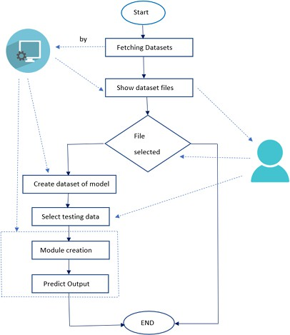

# Fig no. 1. Flow Chart for Project

**Conclusion**

In conclusion, the project " Predicting Software Developer Salaries" offers a comprehensive solution to the challenge of accurately forecasting the salaries of software developers. Through meticulous data collection, preprocessing, feature engineering, and model training, we have developed a robust predictive model using Gradient Boosting Regression.

salaryprediction

[1]:

**import pandas as pd**

**import matplotlib.pyplot as plt**

df = pd.read_csv("survey_results_public.csv")

* + 1. **DATA CLEANING**

[2]:

df.head()

|  |  |  |  |  |  |  |  |  |  |  |
| --- | --- | --- | --- | --- | --- | --- | --- | --- | --- | --- |
| [2]: |  | Respondent | |  | | MainBranch | | | Hobbyist | \ |
|  | 0 | 1 | |  | | I am a developer by profession | | | Yes |  |
|  | 1 | 2 | |  | | I am a developer by profession | | | No |  |
|  | 2 | 3 | |  | | I code primarily as a hobby | | | Yes |  |
|  | 3 | 4 | |  | | I am a developer by profession | | | Yes |  |
|  | 4 | 5 | | I used to be | | a developer by profession, but no… | | | Yes |  |
|  | | Age | Age1stCode | | CompFreq | CompTotal | ConvertedComp |  | Country | \ |
| 0 | | NaN | 13 | | Monthly | NaN | NaN |  | Germany |  |
| 1 | | NaN | 19 | | NaN | NaN | NaN | United | Kingdom |  |
| 2 NaN | | | 15 | | NaN | NaN | NaN | Russian Federation | | |
| 3 25.0 | | | 18 | | NaN | NaN | NaN | Albania | | |
| 4 31.0 | | | 16 | | NaN | NaN | NaN | United States | | |

|  |  |  |  |  |  |
| --- | --- | --- | --- | --- | --- |
| CurrencyDesc | … |  |  | SurveyEase | SurveyLength \ |
| 0 European Euro | … | Neither | easy | nor difficult | Appropriate in length |
| 1 Pound sterling | … |  |  | NaN | NaN |
| 2 NaN | … | Neither | easy | nor difficult | Appropriate in length |
| 3 Albanian lek | … |  |  | NaN | NaN |
| 4 NaN | … |  |  | Easy | Too short |

Trans UndergradMajor \

1. No Computer science, computer engineering, or sof…
2. NaN Computer science, computer engineering, or sof…
3. NaN NaN
4. No Computer science, computer engineering, or sof…
5. No Computer science, computer engineering, or sof…

WebframeDesireNextYear WebframeWorkedWith \

1. ASP.NET Core ASP.NET;ASP.NET Core
2. NaN NaN
3. NaN NaN
4. NaN NaN
5. Django;Ruby on Rails Ruby on Rails

WelcomeChange WorkWeekHrs YearsCode YearsCodePro

|  |  |  |  |
| --- | --- | --- | --- |
| 0 Just as welcome now as I felt last year | 50.0 | 36 | 27 |
| 1 Somewhat more welcome now than last year | NaN | 7 | 4 |
| 2 Somewhat more welcome now than last year | NaN | 4 | NaN |
| 3 Somewhat less welcome now than last year | 40.0 | 7 | 4 |
| 4 Just as welcome now as I felt last year | NaN | 15 | 8 |

[5 rows x 61 columns]

[3]:

df = df[["Country", "EdLevel", "YearsCodePro", "Employment", "ConvertedComp"]] ␣

𝗌*# keep this 4 columns inly*

df = df.rename({"ConvertedComp": "Salary"}, axis=1) *#replacing convertedcomp*␣

𝗌*to salary*

df.head()

|  |  |  |  |
| --- | --- | --- | --- |
| [3]: |  | Country | EdLevel \ |
|  | 0 | Germany | Master’s degree (M.A., M.S., M.Eng., MBA, etc.) |
|  | 1 | United Kingdom | Bachelor’s degree (B.A., B.S., B.Eng., etc.) |
|  | 2 | Russian Federation | NaN |
|  | 3 | Albania | Master’s degree (M.A., M.S., M.Eng., MBA, etc.) |
|  | 4 | United States | Bachelor’s degree (B.A., B.S., B.Eng., etc.) |

[4]:

df = df[df["Salary"].notnull()] *#removing null values*

df.head()

YearsCodePro Employment Salary

1. 27 Independent contractor, freelancer, or self-em… NaN
2. 4 Employed full-time NaN
3. NaN NaN NaN
4. 4 NaN NaN
5. 8 Employed full-time NaN
6. : Country EdLevel \

7 United States Bachelor’s degree (B.A., B.S., B.Eng., etc.)

1. United Kingdom Master’s degree (M.A., M.S., M.Eng., MBA, etc.)
2. United Kingdom Bachelor’s degree (B.A., B.S., B.Eng., etc.)
3. Spain Some college/university study without earning …
4. Netherlands Secondary school (e.g. American high school, G…

YearsCodePro Employment Salary

|  |  |
| --- | --- |
| 7 13 Employed full-time | 116000.0 |
| 9 4 Employed full-time | 32315.0 |
| 10 2 Employed full-time | 40070.0 |
| 11 7 Employed full-time | 14268.0 |
| 12 20 Employed full-time | 38916.0 |

1. :
2. :

df.info()

<class 'pandas.core.frame.DataFrame'> Index: 34756 entries, 7 to 64154

Data columns (total 5 columns):

# Column Non-Null Count Dtype

1. Country 34756 non-null object
2. EdLevel 34188 non-null object
3. YearsCodePro 34621 non-null object
4. Employment 34717 non-null object
5. Salary 34756 non-null float64 dtypes: float64(1), object(4)

memory usage: 1.6+ MB

df = df.dropna() *#drop all the rows not a number*

df.isnull().sum() *#counting null values*

1. : Country 0

EdLevel 0

YearsCodePro 0

Employment 0

Salary 0

dtype: int64

1. :

df = df[df["Employment"] == "Employed full-time"] *#only where the user was*␣

𝗌*employed full time*

df = df.drop("Employment", axis=1) df.info()

<class 'pandas.core.frame.DataFrame'> Index: 30019 entries, 7 to 64154

Data columns (total 4 columns):

# Column Non-Null Count Dtype

* 1. Country 30019 non-null object
  2. EdLevel 30019 non-null object
  3. YearsCodePro 30019 non-null object
  4. Salary 30019 non-null float64 dtypes: float64(1), object(3)

memory usage: 1.1+ MB

1. :

df['Country'].value_counts() *#cleaning the country data*

1. : Country

United States 7569

India 2425

United Kingdom 2287

Germany 1903

Canada 1178

…

Benin 1

Fiji 1

San Marino 1

Guinea 1

Andorra 1

Name: count, Length: 154, dtype: int64

1. :

**def** shorten_categories(categories, cutoff): categorical_map = {}

**for** i **in** range(len(categories)):

**if** categories.values[i] >= cutoff: categorical_map[categories.index[i]] = categories.index[i]

**else**:

categorical_map[categories.index[i]] = 'Other'

**return** categorical_map

*#converting the countries less than 400 employess into one grp*

1. :

country_map = shorten_categories(df.Country.value_counts(), 400) df['Country'] = df['Country'].map(country_map) df.Country.value_counts()

|  |  |  |
| --- | --- | --- |
| [10]: | Country |  |
|  | Other | 8549 |
|  | United States | 7569 |
|  | India | 2425 |
|  | United Kingdom | 2287 |
|  | Germany | 1903 |
|  | Canada | 1178 |
|  | Brazil | 991 |
|  | France | 972 |
|  | Spain | 670 |
|  | Australia | 659 |
|  | Netherlands | 654 |
|  | Poland | 566 |
|  | Italy | 560 |
|  | Russian Federation | 522 |
|  | Sweden | 514 |

Name: count, dtype: int64

1. :

fig, ax = plt.subplots(1,1, figsize=(12, 7)) df.boxplot('Salary', 'Country', ax=ax) plt.suptitle('Salary (US$) v Country') plt.title('')

plt.ylabel('Salary') plt.xticks(rotation=90) plt.show()

*#box plot for salary vs countries*

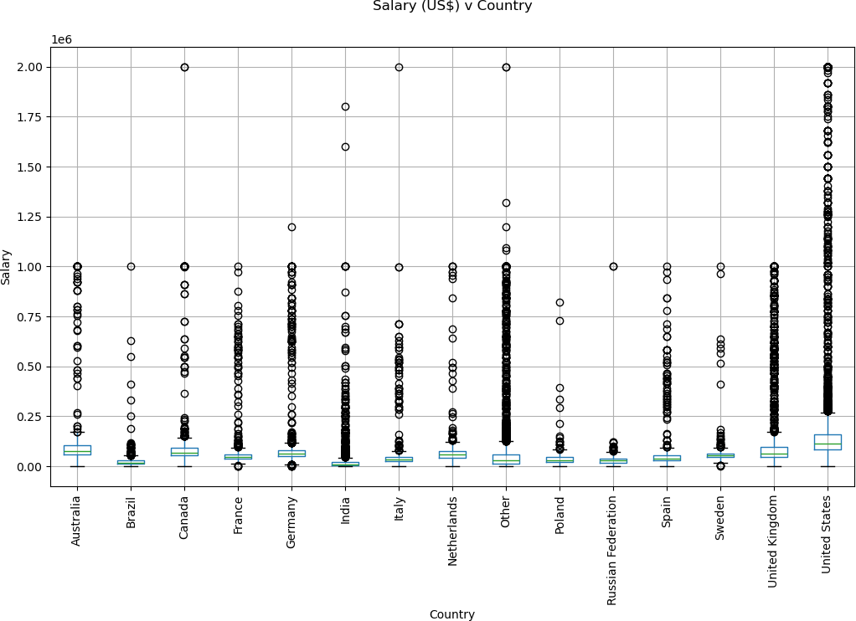

1. :

df = df[df["Salary"] <= 250000] df = df[df["Salary"] >= 10000]

df = df[df['Country'] != 'Other']

*#all the salaries near to the median only taken*

1. :

fig, ax = plt.subplots(1,1, figsize=(12, 7)) df.boxplot('Salary', 'Country', ax=ax) plt.suptitle('Salary (US$) v Country') plt.title('')

plt.ylabel('Salary') plt.xticks(rotation=90) plt.show()

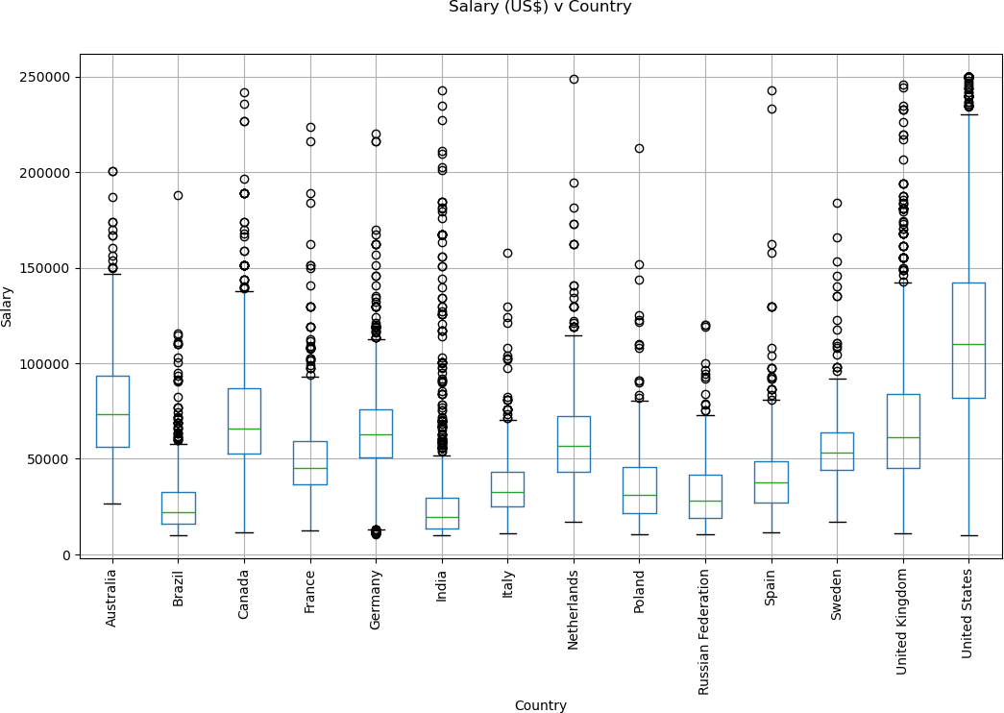

1. :

df["YearsCodePro"].unique()

1. : array(['13', '4', '2', '7', '20', '1', '3', '10', '12', '29', '6', '28',

'8', '23', '15', '25', '9', '11', 'Less than 1 year', '5', '21',

'16', '18', '14', '32', '19', '22', '38', '30', '26', '27', '17',

'24', '34', '35', '33', '36', '40', '39', 'More than 50 years',

'31', '37', '41', '45', '42', '44', '43', '50', '49'], dtype=object)

1. :

**def** clean_experience(x):

**if** x == 'More than 50 years':

**return** 50

**if** x == 'Less than 1 year':

**return** 0.5

**return** float(x)

df['YearsCodePro'] = df['YearsCodePro'].apply(clean_experience)

*#converting experience less than 1 year to 0.5 and more than 50 years to 50*

1. :

df["EdLevel"].unique() *#same with the education level*

1. : array(['Bachelor’s degree (B.A., B.S., B.Eng., etc.)',

'Master’s degree (M.A., M.S., M.Eng., MBA, etc.)',

'Some college/university study without earning a degree', 'Secondary school (e.g. American high school, German Realschule or

Gymnasium, etc.)',

'Associate degree (A.A., A.S., etc.)', 'Professional degree (JD, MD, etc.)',

'Other doctoral degree (Ph.D., Ed.D., etc.)', 'I never completed any formal education', 'Primary/elementary school'], dtype=object)

1. :

**def** clean_education(x):

**if** 'Bachelor’s degree' **in** x:

**return** 'Bachelor’s degree'

**if** 'Master’s degree' **in** x:

**return** 'Master’s degree'

**if** 'Professional degree' **in** x **or** 'Other doctoral' **in** x:

**return** 'Post grad'

**return** 'Less than a Bachelors'

df['EdLevel'] = df['EdLevel'].apply(clean_education)

1. :

df["EdLevel"].unique()

1. : array(['Bachelor’s degree', 'Master’s degree', 'Less than a Bachelors', 'Post grad'], dtype=object)
2. :

**from sklearn.preprocessing import** LabelEncoder le_education = LabelEncoder()

df['EdLevel'] = le_education.fit_transform(df['EdLevel']) df["EdLevel"].unique()

*#le.classes_*

*#converting edulevel from string to number*

1. : array([0, 2, 1, 3])
2. :

le_country = LabelEncoder()

df['Country'] = le_country.fit_transform(df['Country']) df["Country"].unique()

*#each country to a unique number*

1. : array([13, 12, 10, 7, 4, 2, 6, 1, 3, 5, 11, 8, 0, 9])
   * 1. **MODEL TRAINING**
2. :

X = df.drop("Salary", axis=1) *#spliting the data*

y = df["Salary"]

1. :

**from sklearn.linear_model import** LinearRegression linear_reg = LinearRegression()

linear_reg.fit(X, y.values)

*#model from sklearn using linear regression*

*#training*

1. : LinearRegression()
2. :

y_pred = linear_reg.predict(X) *#to predict new values #testing*

1. :

**from sklearn.metrics import** mean_squared_error, mean_absolute_error

**import numpy as np**

error = np.sqrt(mean_squared_error(y, y_pred))

*#calculating mse in y and y_prediction*

1. :

error *# error rate is high so we use another model*

[25]: 39274.75368318509

1. :

**from sklearn.tree import** DecisionTreeRegressor dec_tree_reg = DecisionTreeRegressor(random_state=0) dec_tree_reg.fit(X, y.values)

1. : DecisionTreeRegressor(random_state=0)
2. :

y_pred = dec_tree_reg.predict(X)

1. :

error = np.sqrt(mean_squared_error(y, y_pred)) print("$**{:,.02f}**".format(error))

$29,414.94

1. :

**from sklearn.ensemble import** RandomForestRegressor random_forest_reg = RandomForestRegressor(random_state=0) random_forest_reg.fit(X, y.values)

*#one more*

1. : RandomForestRegressor(random_state=0)
2. :

y_pred = random_forest_reg.predict(X)

1. :

error = np.sqrt(mean_squared_error(y, y_pred)) print("$**{:,.02f}**".format(error))

$29,487.31

1. :

**from sklearn.model_selection import** GridSearchCV

max_depth = [**None**, 2,4,6,8,10,12] parameters = {"max_depth": max_depth}

regressor = DecisionTreeRegressor(random_state=0)

gs = GridSearchCV(regressor, parameters, scoring='neg_mean_squared_error') gs.fit(X, y.values)

*#each time evaluates the error using the max value and find the min value*

1. : GridSearchCV(estimator=DecisionTreeRegressor(random_state=0),

param_grid={'max_depth': [None, 2, 4, 6, 8, 10, 12]}, scoring='neg_mean_squared_error')

1. :

regressor = gs.best_estimator_

regressor.fit(X, y.values) y_pred = regressor.predict(X)

error = np.sqrt(mean_squared_error(y, y_pred)) print("$**{:,.02f}**".format(error))

$30,428.51

1. :

X

|  |  |  |  |
| --- | --- | --- | --- |
| [34]: | Country | EdLevel | YearsCodePro |
| 7 | 13 | 0 | 13.0 |
| 9 | 12 | 2 | 4.0 |
| 10 | 12 | 0 | 2.0 |
| 11 | 10 | 1 | 7.0 |
| 12 | 7 | 1 | 20.0 |
| … | … | … | … |
| 64113 | 13 | 1 | 15.0 |
| 64116 | 13 | 0 | 6.0 |
| 64122 | 13 | 1 | 4.0 |
| 64127 | 13 | 3 | 12.0 |
| 64129 | 13 | 2 | 4.0 |

[18491 rows x 3 columns]

1. :

X = np.array([["United States", 'Master’s degree', 15 ]]) X

*#the output will act as a x*

[35]: array([['United States', 'Master’s degree', '15']], dtype='<U15')

[36]:

*#label encoder 0 for country , degree for 1*

X[:, 0] = le_country.transform(X[:,0]) X[:, 1] = le_education.transform(X[:,1])

X = X.astype(float) X

[36]: array([[13., 2., 15.]])

[37]:

y_pred = regressor.predict(X) y_pred

C:\Users\neelk\anaconda3\envs\ml\lib\site-packages\sklearn\base.py:464: UserWarning: X does not have valid feature names, but DecisionTreeRegressor was fitted with feature names

warnings.warn(

[37]: array([139427.26315789])

[42]:

**import pickle** *#to save the model*

[43]:

data = {"model": regressor, "le_country": le_country, "le_education":␣

𝗌le_education}

**with** open('saved_steps.pkl', 'wb') **as** file: pickle.dump(data, file)

*#we create a dictionary open in write binary mode*

[46]:

**with** open('saved_steps.pkl', 'rb') **as** file: data = pickle.load(file)

regressor_loaded = data["model"] le_country = data["le_country"] le_education = data["le_education"] *#we can check it*

[47]:

y_pred = regressor_loaded.predict(X) y_pred

C:\Users\neelk\anaconda3\envs\ml\lib\site-packages\sklearn\base.py:464: UserWarning: X does not have valid feature names, but DecisionTreeRegressor was fitted with feature names

warnings.warn(

[47]: array([139427.26315789])

[48]:

*#we get the some name before and now*

Home Page:

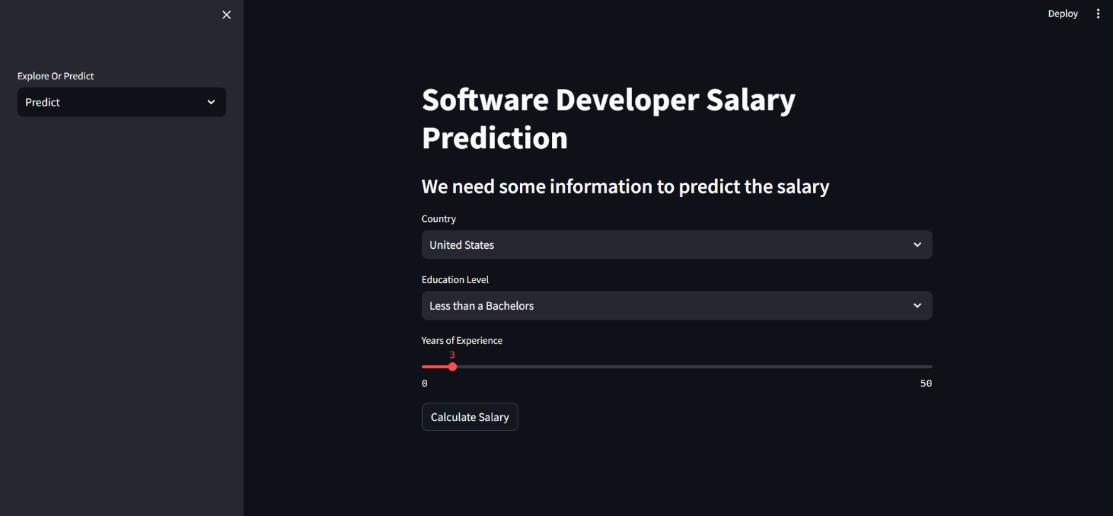

Prediction:

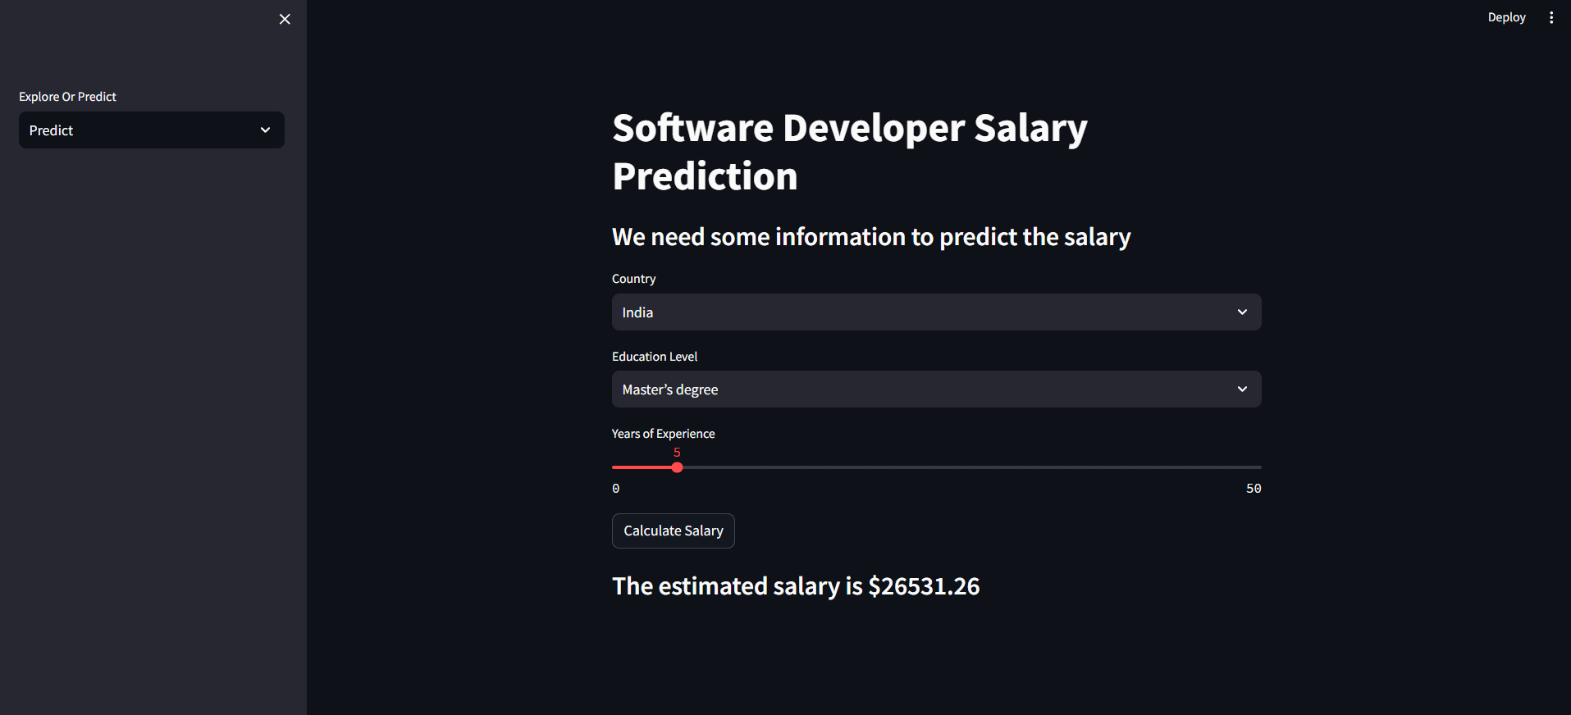

EDA:

